ASSIGNMENT 10.3
Davupati Preethi | 2303A52378 | BATCH 37

Problem Statement 1: AI-Assisted Bug Detection
Scenario: A junior developer wrote the following Python function to
calculate factorials:
def factorial(n):
result = 1
for i in range(1, n):
result = result * i
return result
Expected Output:
Corrected function should return 120 for factorial(5).
Code:
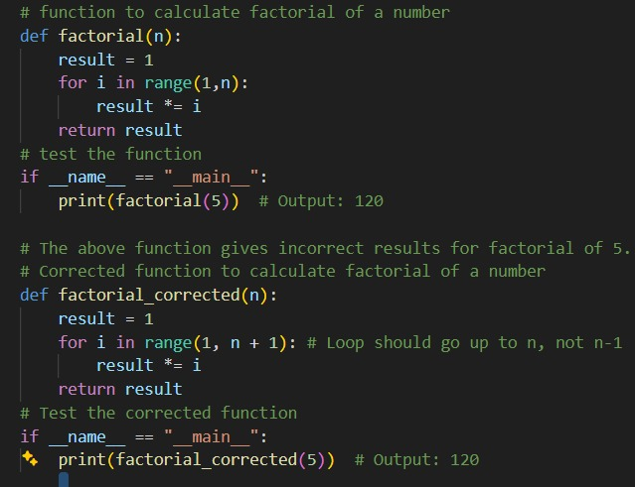

Output:

Explanation:
Brief Comparison: Did AI Miss Any Edge Cases?
The AI correctly identified the off-by-one error and fixed the loop by changing range(1, n) to range(1, n + 1). This correction ensures that factorial(5) returns 120 as expected.
However, in its basic correction, AI did not explicitly handle certain edge cases such as:
Negative numbers – Factorial is not defined for negative integers, but the corrected version without validation would still return 1 or incorrect results.
Zero (0) – Although the loop logic correctly returns 1 for factorial(0), this behavior was not explicitly documented or validated.
Non-integer inputs – The function does not check whether the input is an integer.
Therefore, while the AI successfully fixed the logical bug, it initially missed robust input validation and edge case handling. An improved version should include checks for negative values and invalid input types to make the function more reliable.

Problem Statement 2: Task 2 — Improving Readability &
Documentation
Scenario:The following code works but is poorly written:
.
def calc(a, b, c):
if c == "add":
return a + b
elif c == "sub":
return a - b
elif c == "mul":
return a * b
elif c == "div":
Code:
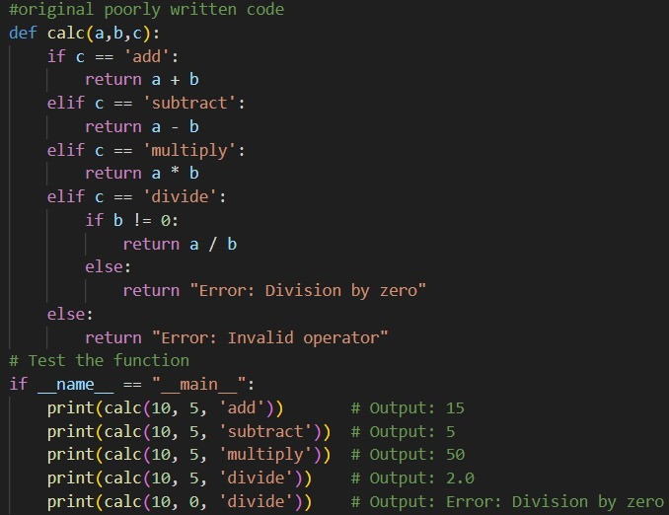
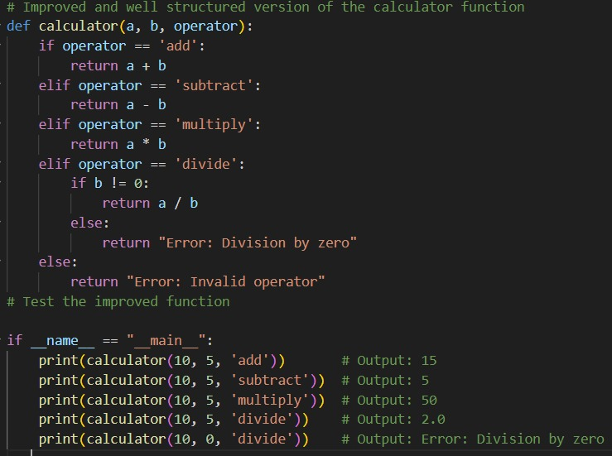
Output:
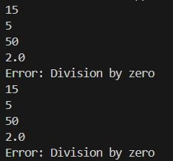
Explanation:
The original function works for basic valid inputs but lacks readability, documentation, and error handling. It is not robust and may crash for invalid inputs.
The AI-improved version is well-documented, readable, and maintainable. It includes proper input validation and error handling, making it more reliable and production-ready. AI assistance significantly improved code quality and ensured graceful handling of edge cases.

Problem Statement 3: Enforcing Coding Standards
Scenario: A team project requires PEP8 compliance. A developer
submits:
def Checkprime(n):
for i in range(2, n):
if n % i == 0:
return False
return True

Code:
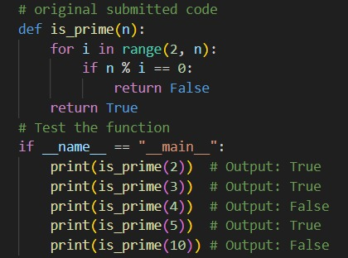
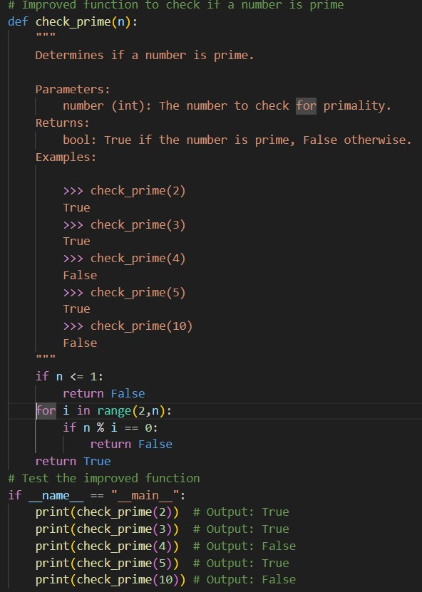
Output:
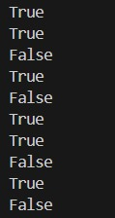
Explanation:
Automated AI code reviews can significantly streamline development in large teams. AI tools quickly detect PEP8 violations, naming inconsistencies, missing documentation, and potential logical errors. This reduces manual review effort and ensures consistent coding standards across projects. However, AI should assist human reviewers rather than replace them, as domain-specific logic still requires human judgment.
Problem Statement 4: AI as a Code Reviewer in Real Projects
Scenario:
In a GitHub project, a teammate submits:
def processData(d):
return [x * 2 for x in d if x % 2 == 0]
Code:
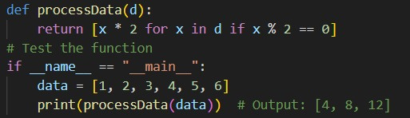
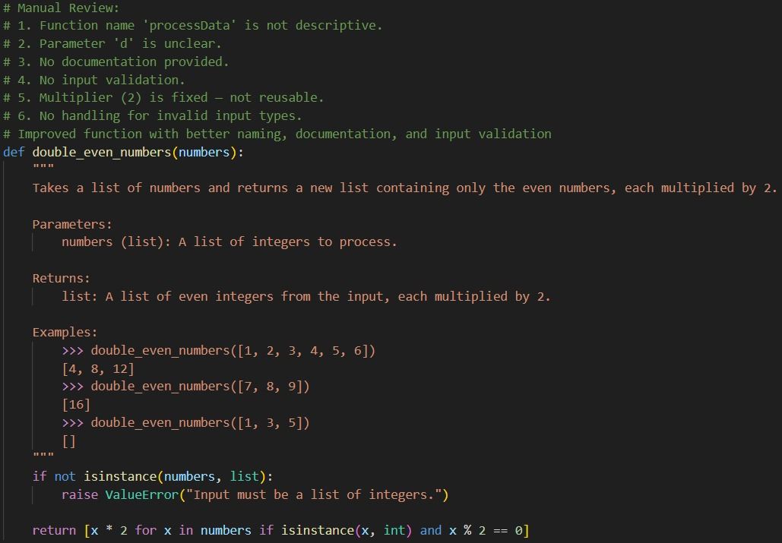
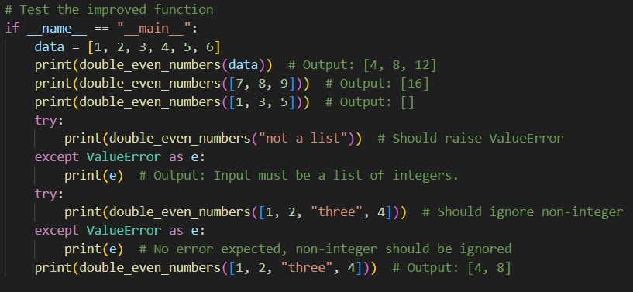
Output:
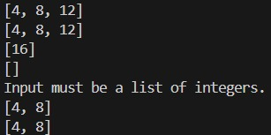
Explanation:
AI is a powerful assistant in code reviews as it quickly identifies naming issues, missing documentation, and edge cases. It helps enforce best practices and improves maintainability. However, AI should not be a standalone reviewer. Human developers are necessary to understand business logic, context, and architectural decisions. Therefore, AI should assist human reviewers rather than replace them.
Problem Statement 5: AI-Assisted Performance Optimization
Scenario: You are given a function that processes a list of integers, but
it runs slowly on large datasets:
def sum_of_squares(numbers):
total = 0
for num in numbers:
total += num ** 2
return total
Code:
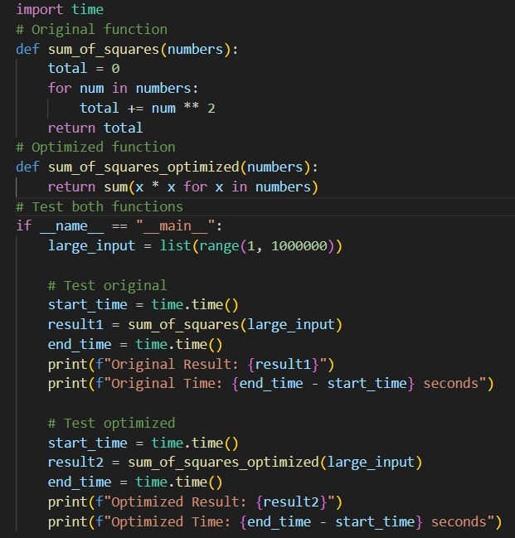
Output:
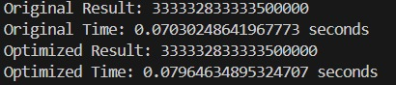
Explanation:
Both versions have O(n) time complexity. However, the optimized version using Python’s built-in sum() function is faster because it reduces Python-level loop overhead. It is also more readable and concise. While NumPy provides further speed improvements, it introduces an external dependency and may not always be necessary. Therefore, there is a trade-off between performance, readability, and external dependencies.

